

KS1- KS1 Road Warrior

MIDI 9 MIDI ADAPTER

INSTALLATION MANUAL

MIDI 9
800-757-MIDI
www.midi9.com

MIDI 9 KS1-KS1 Road Warrior

INSTALLATION MANUAL

TABLE OF CONTENTS

INTRODUCTION 3
OVERVIEW 4
INSTALLATION 8
INVENTORY OF PARTS 8
PRE-INSTALLATION CHECKOUT 10
DISASSEMBLE PIANO 11
VERIFY CLEARANCE BELOW KEYS 11
SECURE KEYBOARD SENSOR STRIP 13
INSTALL CONTROL UNIT 13
ROUTE SENSOR STRIP WIRING 13
REPLACE ALL KEYS 14
INSTALL PEDAL SENSOR 14
CONNECT POWER AND EXTERNAL ACCESSORIES 18
PERFORM KEYBOARD ADJUSTMENT 18
TEST 19
STUCK, STICKY, OR BROKEN ACTUATOR FINGERS 19
INDEX 21

INTRODUCTION

This manual covers installation (including unpacking, pre-installation checkout, necessary adjustments, and tuning) of the KS1 piano keyboard scanning system. This product is a keyboard scanner accessory that may be installed on any conventional 88-note vertical or grand piano and many other keyboard products. The controls are contained in a stationary control panel. The default velocity curve of the KS1 is a general-purpose exponential curve. If you desire different velocity curves or more flexible setups, they can be accessed using system exclusive command built into the Midi 9 configuration software (www.midi9.com 800 757-6434).

We strongly suggest that the pre-installation checkout be done at your place of business before going to a customer's home for installation into a piano. In this way you will be able to determine if any components were damaged during shipping.

Please leave this manual with the customer in case it is needed for future reference.

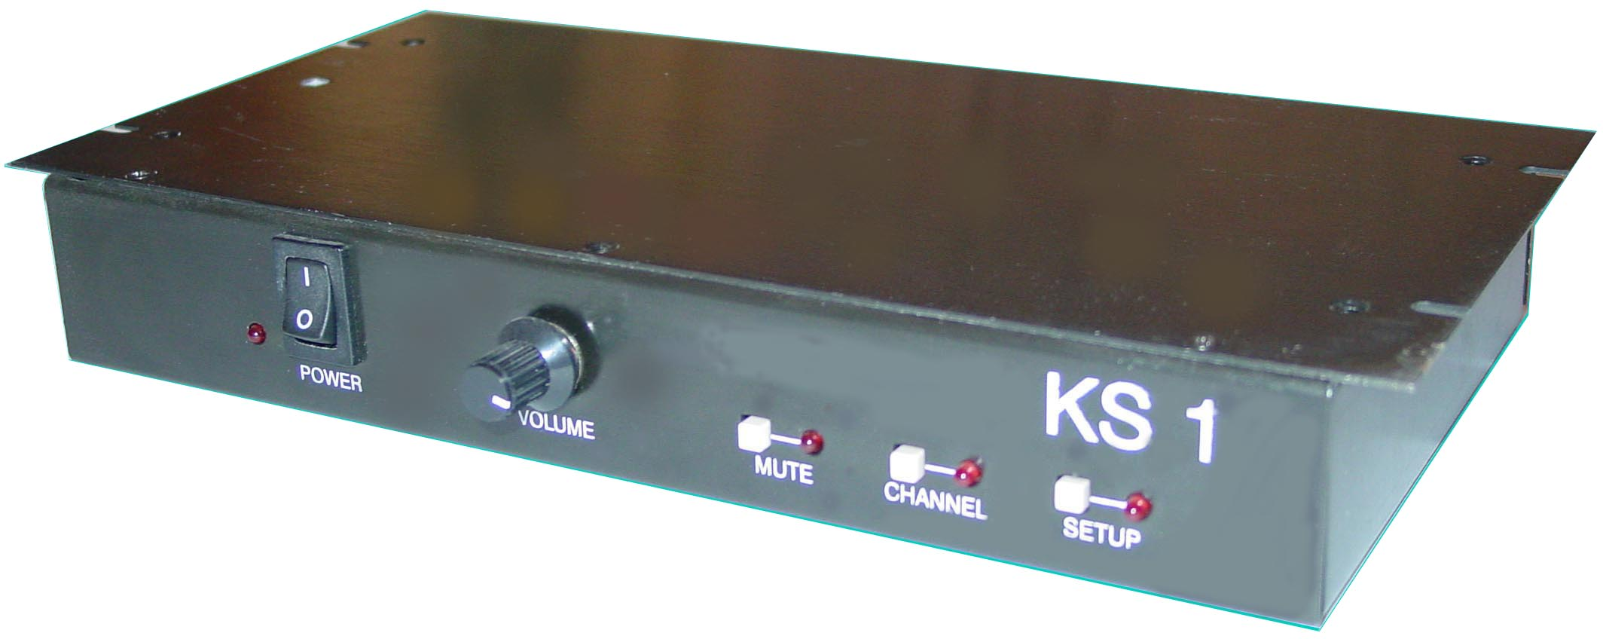

Midi 9 KS 1 Control Unit

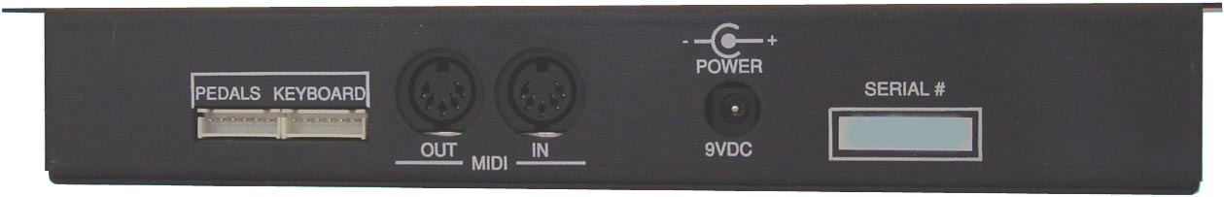

Midi 9 KS 1 Control Unit Rear Panel

OVERVIEW OF THE MIDI 9 KEYBOARD SCANNING SYSTEM

This is a brief overview of how the Midi 9 keyboard scanning system works. You may find this information helpful if you have never installed a Midi 9 keyboard product before.

The patented Midi 9 system consists of three basic components: a Keyboard Sensor, Strip, a Pedal Sensor, and Control Unit.

Keyboard Sensor: The keyboard Sensor Strip is a series of optical sensors, one for each key. Each optical sensor has two small plastic "towers." One tower transmits a beam of infrared light to the other tower, which detects infrared light. There is a small spring-loaded actuator finger that serves as a shutter by blocking the light beam. It gradually reduces the amount of light detected as it is depressed. The sensor strip is mounted beneath the keyboard, positioned so that an actuator touches the bottom of each key. The actuator's position is maintained by its spring (which exerts roughly 3 grams of force − much less than the mass of the key and is therefore undetectable by the player). The travel of the key is not restricted by the sensor strip − each key still has the same range of motion it had before, only now there is a low-mass actuator tracing its movement, collecting data for the control unit. The complete sensor strip consists of four printed circuit (PC) boards mounted to a steel plate. The individual sensors are soldered to the PC boards and are aligned by two stainless steel rods that run the entire length of the sensor strip.

Pedal Sensor: An SSM1 is shipped with the KS1-. The SSM1 is used to detect motion of the sustain pedal. It is a reed switch that is attached to a stationary part of the pedal lyre or pedal assembly. A magnet fastened to the moving parts of the pedal rod or trapwork actuates this On/Off switch. An alternate pedal sensor available from Midi 9, the SS5, provides discrete position sensing of all three piano pedals. This sensor has three actuators identical to those found on the keyboard sensor strip. The sensor is attached to the pedal lyre on grand pianos, and underneath the keybed behind the kickboard on uprights.

Control Unit: The KS1 transmits and receives MIDI data, allowing the user to connect with external synthesizers and sequencers.

On which keyboard instruments can I install a Midi 9 sensor strip? The SS88 was designed in such a manner that it can be installed in virtually any piano. For most acoustic pianos the installation process is straightforward. Occasionally with pianos, and more frequently with organs and other keyboards, a successful installation will require some creativity on the installer's part. Remember that the objective is to have each keys move an actuator without affecting the instrument's "feel." There are two factors that will determine whether this is difficult − key clearance and the number of keys.
Acoustic pianos: There must be enough room between the bottom of the key and the highest portion of the keybed so that the key does not hit the sensor housing. Fortunately, for most acoustic pianos this is not a problem. If the gap between the top of the keybed and the bottom of a depressed key is 18 mm (.7") or greater, the sensor strip can be installed without modification. If the gap is less than 18 mm but greater than 15 mm (.6"), the sensor strip can be removed from its metal plate and the PC boards can be screwed directly into the keyframe using insulators supplied with the Sensor Strip. If the clearance is less than 15 mm, it will be necessary to rout a "trough" in the keyframe to allow enough room for the sensor strip. (This will not affect the action). We only know of one very old grand piano in which the keyframe was too thin to rout without adversely affecting its structural integrity. In that case we advised against the installation of a sensor strip.

Electric pianos: The same clearance requirements exist as in acoustic pianos. In particular, for Rhodes 73- and 88-note electric pianos, it may be necessary to rout the keyframe. With the 73-note Mark I, routing is always necessary. For others, it may only be necessary if you wish to keep the sensor strip on its metal backing plate. This is advisable if the piano is going to be moved frequently. The extra support the metal plate provides is not necessary if the piano is not going to be moved often. (If the sensor strip shifts position, it needs to be recalibrated. Although this procedure only takes a moment, it might prove to be an annoyance if it must be performed whenever the piano is moved.) Some people feel that Rhodes pianos should have backchecks installed to prevent key flutter caused by the hammer bouncing around after it has struck the tine. Because of the Rhodes' construction, this hammer motion causes key motion, which is misinterpreted by the sensor strip. Backchecks catch the hammer when a note is released, preventing this unwanted motion. They also make the Rhodes keyboard feel more like that of an acoustic piano.

Organs and other keyboards: Again, the same clearance requirements exist as in acoustic pianos. It is very difficult to generalize about organ installations because the construction of organ keyboards varies more than the construction of piano keyboards. The installer must ensure each key moves an actuator within its acceptable range of motion. On church organs with wooden keys, this may require hanging the sensor strip upside down behind the fulcrum so that the backs of the keys push up on the actuators. Most organs and synthesizers have hollow keys, and because the actuators are all aligned in a row, some creativity is required to find a place where some part of both the white keys and the black keys is accessible. On the Korg BX-3, for example, the fronts of the black keys extend to and are even with the white keys. However, the white keys have an "overbite" which causes them to move any adjacent black key actuators. This "overbite" can be trimmed off with a nibbler or wire cutters.

Number of keys - Gulbransen manufactures and stocks keyboard sensor strips in three different lengths: 88 notes, 73 notes, and 61 notes. A few other custom lengths are also available. (The sensor strip segments are made in lengths of 17 and 22 notes. An 88-note strip is comprised of four 22 note segments, a 73 is three 17s and a 22, and a 61 is a 17 and two 22s. If you need an unusual-length sensor strip, you can special-order one out of any combination of 17- and 22-note segments totaling 88 keys or less.). Often you can use a sensor strip that is a few notes too long by taping down unused actuators and hollowing out a cavity in the cheek block where the extra sensors extend.

INSTALLATION CHECKLIST

This checklist is a summary of all the steps involved installing the Midi 9 keyboard product. The steps on this checklist are in the same order as the detailed descriptions that follow. For this reason you may want to pull this page out so you can keep it handy as you go through the manual (there is an extra copy on the next page). You will find this list helpful if you encounter any problems.

[ ] 1. Inventory of parts. Verify you received everything.

[ ] 2. Pre-installation checkout. Hook up and test components to verify that all components operate correctly.

[ ] 3. Disassemble piano. Disassemble piano to the point where all keys are accessible.

[ ] 4. Verify key travel and clearance below keys.

[ ] 5. Secure keyboard sensor strip.

[ ] 6. Install control unit.

[ ] 7. Attach and route keyboard sensor strip wiring.

[ ] 8. Replace all keys. Replace keyframe.

[ ] 9. Install pedal sensor.

[ ] 10. Connect power and external accessories. Connect all wiring.

[ ] 11. Perform keyboard adjustment.

[ ] 12. Test.

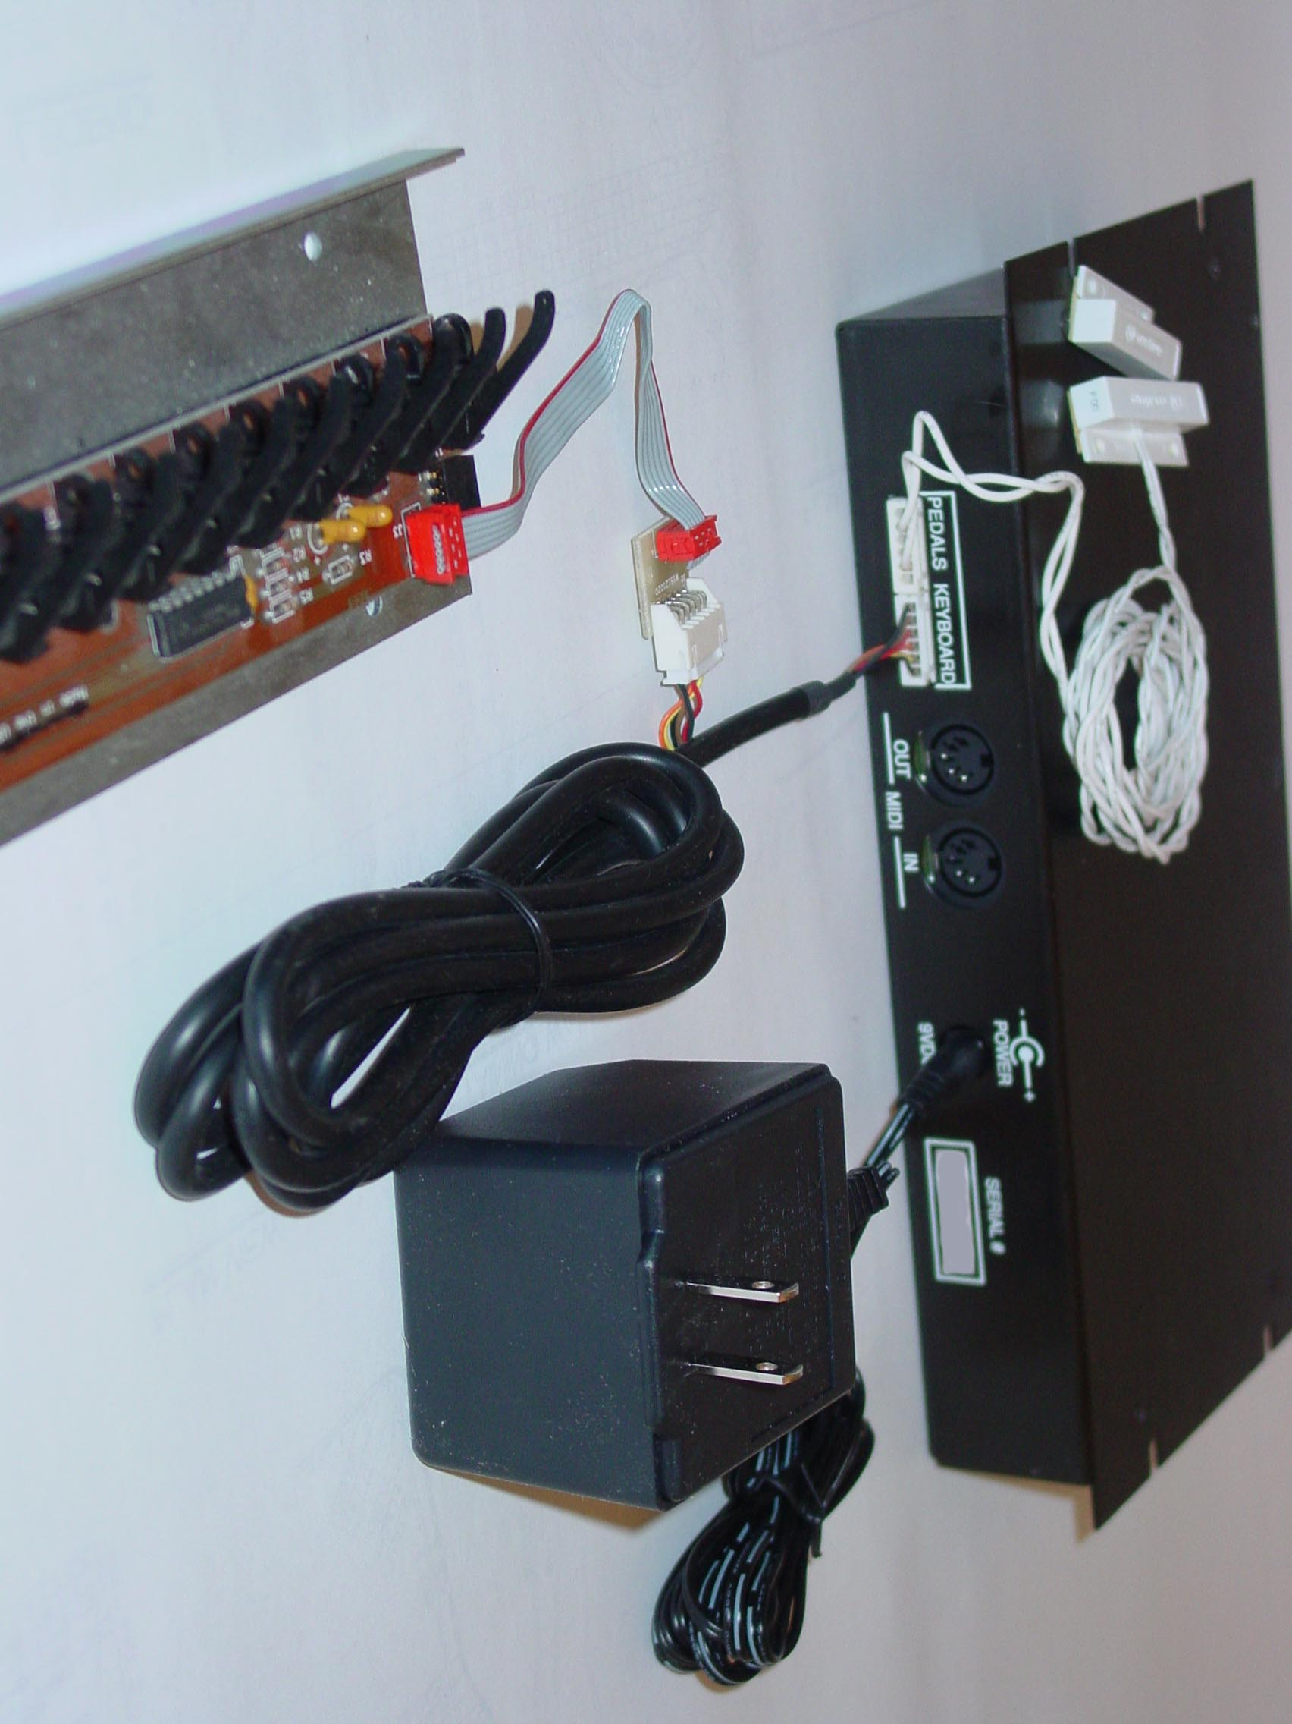

KS1 wiring setup.
INSTALLATION CHECKLIST

INSTALLATION

1. INVENTORY OF PARTS

All components of your Midi 9 product were carefully tested and inspected prior to shipment. They should reach you in perfect operating and cosmetic condition. Please inspect each component as you unpack the system, and report any discrepancies or shortages immediately.

NOTE: Exercise caution when unpacking the Keyboard Sensor Strip from its shipping tube. The actuator fingers can be broken if pushed sideways.

You should receive the components listed in your Owner's Manual:

[ ] One Control Unit
[ ] One SS88, Opto-Electronic Keyboard Sensor Strip
[ ] One long (6') 6-conductor “Connector Cable”
[ ] One short (6") 6-conductor “Grey Cable”
[ ] One 6-conductor Transition Board to connect the Connector Cable to the Grey Cable
[ ] One 12 VDC 1 Amp Power Supply (Wall Transformer)
[ ] One SSM1 Pedal Sensor
[ ] One Hardware Kit consisting of:
[ ] One plastic grommet
[ ] Miscellaneous screws, tie wraps, and other mounting hardware
[ ] Installation Manual (this manual)
[ ] Owner's Manual
[ ] Warranty Registration Card

Keyboard Sensor Strip (SS88 shown) Control Unit

SSM1 Pedal Sensor Power Supply (Wall Transformer)

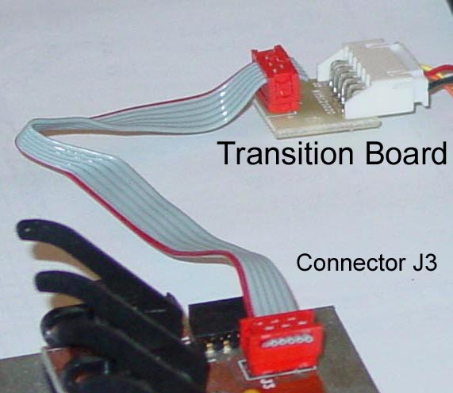

SS5 Pedal Sensor Strip Transition Board “Grey Cable”

2. PRE-INSTALLATION CHECKOUT

The purpose of the Pre-Installation checkout is to verify that no damage occurred in shipping. The installer will then know for certain that all of the components are functioning properly, and that any problems, which arise later, would be associated with the physical installation itself and not due to faulty components.

Hook up the Midi 9 components on a workbench or on the floor:
[ ] Connect the long and the short six-conductor interconnect cables using the extension adapter. Connect the free end of the long cable to the matching 6-pin jack (Keyboard) on the back of the Control Unit.

[ ] With the Keyboard Sensor Strip positioned so that the tips of the actuator fingers are facing you, connect the other end of the cable assembly to the corresponding 6-pin jack labeled J3 on the left end of the Keyboard Sensor Strip.

[ ] Plug the pedal sensor cable into the 6-pin jack labeled Pedals.

[ ] Connect the Power Supply (transformer) mini-plug connector into its matching socket on the back of the Control Unit. Be sure that the connector is fully seated.

[ ] Connect the MIDI Output Jack to the INPUT jack of an external MIDI device, which will allow you to test the Midi 9 MIDI output.

[ ] (Optional) Connect the MIDI INPUT jack to the OUTPUT jack of an external MIDI device, which will allow you to test the Midi 9 MIDI input. All Midi 9 products can change parameters via MIDI System Exclusive.

[ ] Plug the Power Supply into a live 110 volt AC, 60 Hz., and wall outlet.

Now verify that the Midi 9 system has power:

[ ] Turn the Power switch on the control panel to On. Verify that the red pilot light on the front of the control panel turns on and remains lit. (Push m to turn the power off, push ⎯ to turn power on)

[ ] Press some of the control buttons. Verify that their indicator lights come on as they are depressed. (See the Owner's Manual for operational details.)

Perform an initial keyboard adjustment:

[ ] Enter Keyboard Adjustment mode:
Press the Setup switch located in the right of the control panel. When the Setup switch is activated, the Setup light will begin flash. You are now in the Keyboard Adjustment Mode.

[ ] Perform Keyboard Adjustment:
Beginning with the leftmost end of the Keyboard Sensor Strip (end nearest connector J1), and moving from left to right, carefully depress and release each of the actuator fingers. DO NOT PUSH THE FINGERS SIDEWAYS OR BREAKAGE MAY OCCUR.

[ ] Exit Keyboard Adjustment mode:
Press the Setup button. The Setup light will stop flashing indicating that the unit has left the Keyboard Adjustment Mode.
[ ] Test the MIDI Output by pressing each of the actuator fingers on the sensor strip and verifying that the external MIDI device is responding.

[ ] Turn the power switch to OFF, unplug the Power Supply (wall transformer) and disconnect the Midi 9 product components. When disconnecting any of the six-conductor interconnect cables be sure to grab the plugs by the plastic end connectors whenever possible to avoid damaging the cables.

If any problems are encountered, recheck all of the cable connections and try again. See also the Troubleshooting section in the Owner's Manual.

3. DISASSEMBLE PIANO

Disassemble the piano casework so that the piano keys are fully exposed and can be removed from the keyframe. On vertical pianos, also remove the kick board. On grand pianos it will be necessary to remove the entire keyframe from the piano, and then remove the hammer assembly from the keyframe.

Remove all 88 keys and set them aside in sequence for later ease of replacement. (It's a good idea to make sure the keys are legibly numbered before doing this!)

6. VERIFY CLEARANCE BELOW KEYS

Place the sensor strip in the keyframe between the balance rail and the front pins with the tips of the actuators pointing toward the front pins. (Refer to Figure 1).

Figure 1 - Keyboard Sensor Strip Placement

If you cannot lay the sensor strip flat because of an obstruction in the keybed, you may have to cut the obstructing piece of keyframe. Alternatively, the sensor strip can be removed from the backing plate. The sensor strip itself is much narrower than the attached metal 70 mm (2.75") backing plate. See the section "If There Is Not Enough Clearance," below.

Replace the highest and lowest black keys. Check the left-right alignment of the actuator fingers at each end of the Keyboard Sensor Strip. Each finger should be centered beneath its corresponding key. If the fingers are not centered, you may need to remove both keys to shift the Keyboard Sensor Strip left or right as required, then replace the two keys and check the alignment again. Repeat this process until the fingers are as centered as possible. Do not try to shift the sensor strip from side to side with the actuators resting against the bottoms any keys − remove the keys. It is very easy to break the actuators if they are pushed sideways. Most pianos have a standard key spacing. If your piano has narrower spacing, make the best compromise. Place a pencil mark on the keybed at each end of the Keyboard Sensor Strip to mark the correct left-right alignment.

Figure 2A - Actuator before installation of keys.

Figure 2B - Rest position (key fully up). Actuator finger depressed 5 mm (.2").

Figure 2C - Key down (without compressing felt). Actuator not fully depressed.

Figure 2 - Actuator Movement

Proper operation depends on the travel of the actuator (see Figure 2). Each of the following requirements must be met:

[ ] In the rest position (key in its normal fully-up position), each actuator should be depressed by the underside of the key at least 5 mm (.2"). (This distance is measured at the tip of the actuator and is about the height of a stack of four dimes); a little more depression is acceptable, but not more than 8 mm (.3"). This is important. If the actuator finger is not depressed between 5 mm and 8 mm at the rest position of the key, it is likely that the sensor will malfunction.

[ ] The actuator travel should be between 4 mm (.16") and 10 mm (.4"). The actuator travel is the distance that the actuator travels (measured at the tip of the actuator) as the key moves from the key's rest position to the key's fully down position. It is desirable to get as much actuator travel as allowable by locating the sensor strip as far from the balance rail (fulcrum) as possible. (More than 10 mm of travel is not desirable, since too much travel will cause the actuator to dip below the point where the long portion of the actuator is parallel to the circuit board (travel below this point is not recognized by the scanning system and is therefore unusable).

[ ] Be sure that the key does not hit the sensor housing when fully depressed, and that the tip of the actuator does not hit any part of the piano keyframe. Strike the key firmly and listen for clicking.

By moving the entire Keyboard Sensor Strip toward or away from the front of the piano, attempt to find a spot where these alignment requirements are met. Usually the best results are obtained with the sensor strip as far forward (towards the player) as possible.

If there is too little clearance, remove the sensor strip from the steel backing plate. This will give you an extra 2.5 mm (.1"). Attempt to align the assembly as described above, but without the metal base. A long narrow plastic insulator strip is provided underneath each of the four PC boards. Use pieces of the plastic insulator strip (cut with scissors) underneath the PC board wherever it touches the keyframe to prevent possible short circuits due to moisture (humidity) transmission. Once you have found the right location for the sensor strip, gently depress each of the actuators to make sure they still move freely. (The steel plate keeps the PC board segments spaced properly. Without the steel plate the PC board segments can become spaced too tightly. When this happens the actuators adjacent to the ends of the PC boards can stick.) Do not allow the tips of the actuators to touch the front key felts when the keys are fully depressed. If there is too much clearance now that the metal base has been removed, use shims between the sensor strip and the keybed. Paint-stirring sticks and Popsicle sticks make good shims.

NOTE: In some instances it will be necessary to rout the keyframe in order to achieve the necessary clearance.

If there is too much clearance, Reduce the clearance by placing wooden shims or spacers (not provided) beneath the metal base of the Keyboard Sensor Strip. Once again, paint-stirring sticks and Popsicle sticks make good shims.

7. SECURE KEYBOARD SENSOR STRIP

If you are mounting the sensor strip with the metal backing plate: Use the screws provided in the hardware kit to screw the metal plate to the keyframe. Verify the alignment after securing.

If you are mounting the sensor strip without the metal backing plate: On grand pianos, there are usually five braces on the keyframe that will supply ample support for the sensor strip PC board assembly. In a vertical piano there may only be three braces − use shims (not supplied) or suitable blocks of wood to provide support so that the sensor strip PC board assembly does not sag. Screw the sensor strip PC board assembly directly to the keyframe. Do not drill any additional holes in the printed circuit boards. To do so could damage the small copper traces on them. Use the same holes that were used to secure the boards to the metal base.

Check the actuators adjacent to the joints of the PC boards. Without the support of the backing plate, these can become spaced too tightly and stick. If you find that one of these is binding, loosen all the screws fastening the PC boards to the keyframe. With a large, flat screwdriver, gently pry the two PC boards apart. You will not have to move them very far. Tighten all the screws and verify that fixing this actuator did not cause another to bind.

8. INSTALL CONTROL UNIT

Most people prefer to have the Control Unit mounted to their left so they can continue playing with their right hand while selecting sounds, adjusting the volume, etc.

9. ROUTE SENSOR STRIP WIRING

You will need to route the long Connector Cables from Transition Board on the Keyboard Sensor Strip to the back of the Control Unit. Inspect all cable connectors carefully to insure that the proper polarity is maintained when the connections are made.

On grand pianos: The short Grey Cable and Transition Board are used to provide a quick disconnection of the keyframe from the rest of the piano. This will facilitate removal of the keyframe in the future. The short Grey Cable will always be attached to the sensor strip. The long cable is connected to the control unit on one end, and the Transition Board on the other. This Transition Board can be mounted to the inside of the piano case if desired. (Make sure the mounting location does not interfere with the operation of the fallboard.) In the future, if it becomes necessary to remove the keyframe, the technician can simply unplug the keyframe from the Transition Board and pull it out.

Route the Connector Cable from the jack labeled Keyboard on the back of the Control Unit up through to the left side of the keyboard. Usually you can run the cable through an access hole for one of the pedal action rods. Make sure the cable does not interfere with the pedal action. Alternately, you can drill a 13 mm (1/2") hole in the keybed to route the cable. Make sure the wiring is well clear of where the hammers will be. Also be sure the wiring does not interfere with the sustain pedal mechanism at the back of the keyframe cavity. When you are finished, secure the wiring with the tie wraps provided. Make sure any slack is left underneath the piano. You will need some of this slack below so you can slide the control unit in and out.

On vertical pianos: The vertical piano installation is the same as the grand piano installation, but the action remains permanently in the piano. Dress the wire, leaving any slack underneath the keyboard. You will need some slack to slide the control unit in and out. Any excess can be dressed behind the kickboard. Be sure the routing of the wiring does not interfere with the movement of the piano keys.

10. REPLACE ALL KEYS

Replace all keys. Make sure all keys move freely. There should be no clicking and no interference from the sensor strip cabling.

On grand pianos: Replace the hammer assembly. Replace the keyframe and plug the short extension cables on the keyframe into the adapter(s) inside the piano. Ensure that the cables do not interfere with the piano action in any way. Also check that the cables are not pinched or scraped by the movement of the grand-piano keyframe when the soft pedal is pressed. Affix a Warning Label in a conspicuous location near the leftmost Transition Board so that the piano technician who next services the piano will be made aware that a Sensor Strip is hiding under the keys, making sure this label is not visible when the fallboard is in place.

Reassemble and replace the keyframe. Play each note to verify that all keys move freely. If there is a problem check to see whether it is caused by the keyboard sensor wiring interfering with the piano action. Reroute the wiring as required.

11. INSTALL PEDAL SENSOR

This section of the installation manual discusses the installation of the SSM1 Pedal Sensor and the optional SS5 Pedal Sensor Strip. The SSM1 senses movement of the sustain pedal, while the SS5 detects motion of all three piano pedals. You will only be using one of these sensors. If you are using the optional sensing mechanism, skip down to "SS5 Pedal Sensor Strip Installation" below.

SSM1 Pedal Sensor Installation:

This section of the manual describes the installation of the SSM1 in grand and vertical pianos. Keep in mind that these instructions are general and are not cast in stone − if a particular installation presents you with an opportunity to mount the pedal sensor in a better location, by all means do so.

The SSM1 is a magnetic reed switch. The switch is normally open. When the magnet is within a certain distance of the switch, typically about 25 mm (1"), the switch closes. This is only true if the switch and magnet are parallel with each other. If they are perpendicular, the magnet must be closer before the switch closes. You can use this characteristic to your advantage if you decide to mount the switch to the trap work or some other place where you have less than 25 mm of clearance between the two switch components.

There is often a fair amount of travel in the sustain pedal. You will want the switch to close just as the piano begins sustaining. Playing a sustaining sound, such as an organ, can test this. Strike a note repeatedly while slowly pressing and releasing the sustain pedal. A continuity tester can be helpful for this task.

If you find a location that is "backwards" - that is, the switch opens just as the piano begins sustaining, that's okay. You can tell the control unit to change the polarity of the switch in software in the event. (Refer to the Index of the Owner's Manual for details. Look under "polarity.")

Installing the SSM1 on Grand Pianos: Attach one of the plastic clamp washers to the sustain pedal pushrod. Be sure the smooth side is upward, facing the pedal lyre. Attach the SSM1 switch (the one with the wires) to the pedal lyre using the adhesive backing provided. Attach the SSM1 magnet to the clamp washer. On some pianos, the pedal pushrod can rotate rather freely. This can become a problem if the rotation allows the magnet to rotate out of alignment with the reed switch. If you think this may affect your piano, a better solution may be to attach the magnet to some part of the trap work and mount the reed switch on the keybed. Figure 3 depicts a typical installation.

On Steinways and some others: The push rods may be too narrow for the clamp washer to fit snugly on the pushrod. In that event, use toothpicks or some other material to serve as a wedge.

On Baldwins and some others: There may not be a wooden brace on the pedal lyre. You can fashion one for the purposes of mounting the SSM1 switch, or you may wish to consider mounting the pedal sensor to the sustain pedal trap work.

Figure 3. - Installation of SSM1 on a Grand Piano

Installing the SSM1 on Vertical Pianos: You will need to find a place where you can "capture" the movement of the sustain pedal. In most cases the sustain pedal moves a pushrod on the left side of the piano, near the bass strings. Attach the magnet to the clamp-washer and the clamp-washer to this pushrod. Then attach the switch to the piano casework. You will need to experiment with clearances to get the switch to close just as the piano begins sustaining. If this does not work for you, try mounting the sensor on the sustain pedal itself. Mounting the magnet to the bottom side of the pedal (behind the kickboard) allows you to mount the switch to the cabinetwork below it. (See Figure 6).

SS5 Pedal Sensor Strip Installation:

On grand pianos: Mount the Pedal Sensor Strip on the back of the pedal lyre push rod brace as shown in Figure 4, using the wood screws supplied. By mounting to the lyre, disconnection and reconnection is simplified.

On Baldwins and some others: There may not be a wooden brace on the pedal lyre. You can fashion one for the purposes of mounting the SS5.

Figure 4 - Grand Piano Pedal Sensor Strip Installation
(Viewed from the Rear)

Figure 5. - Pedal Actuator Extenders

(Grand Pianos) Install the three push rod clamp washers as shown in Figure 4. Depress the individual foot pedal and maintain this position. Now slide the clamp washer assembly up until it physically touches the pedal sensor housing. Maintain position and tighten both screws. Release this pedal and repeat the procedure for the remaining pedal shafts. Dress any slack in the interconnect cable using the supplied cable ties. If any of the pedals (particularly the sustain pedal) has more travel than the actuator finger of the Pedal Sensor Strip allows, use one of the finger Extenders as shown in Figure 5. The use of the extender is optional, but will give much better control of the sustain-pedal sensing when the sustain-pedal travel is large. To use the extender, trim the end of the actuator finger so that the extender can be slipped over the stub.

The SS5 Pedal Sensor Strip is designed to accommodate a wide variety of spacings in the pedal lyre push rods. If you look through the slots in the top of the SS5 sheet metal you will see that there are 5 positions in the Pedal Sensor Strip (SS5) where the 3 pedal actuators can be inserted. The default positions for the three actuators are in the middle and on the outside ends. There is a small piece of black tape or tubing covering the sensor windows in the other two positions. The black tape serves to block the light on the unused sensors. This is necessary because the unused positions would otherwise affect the automatic gain setting for the 3 sensors in use. If you need to use one or both of the other positions, use the following procedure:

[ ] Remove the three nuts on the side of the SS5 housing and pull the screws out.
[ ] Gently pry the SS5 PC board out of the sheet metal.
[ ] Note the orientation of the three actuators and their springs. Also note that the actuator is held in place with a small aluminum tube.
[ ] Note that the two unused sensors have plastic tubing on them to prevent light from passing across the gap between the two small towers. Because you will be changing which three of the five sensors you are using, you will want to be sure the unused sensors are blocked. Using a pair of needle nose pliers, pull the tubing off any sensors you plan to use.
[ ] Move the actuator finger(s) and spring(s) to their desired locations
[ ] Replace the tubing on the unused sensors. If the tubing ripped when you removed it, or if it will not fit snugly, use black tape or some other opaque material to block the gap between the two towers of the sensor.
[ ] Reassemble the SS5 and check that the 6-pin jack is accessible through the window in the sheet metal before tightening the screws.

Figure 6. - Vertical Piano SSM1 and SS5 Pedal Sensor Installation
(Both SS5 and SSM1 are shown for illustration only. You will only be using one sensor.)

Figure 7. Vertical Piano SS5 Installation (viewed from sound-board side)

On vertical pianos: The goal for a successful installation is for the actuator arms to remain extended when the piano foot pedals are at rest, and for the actuator arms to by fully depressed when the piano pedals are down. This can be accomplished with the following procedure:

[ ] Attach the two L-brackets to the ends of the Pedal Sensor Strip using the #4-40 machine screws. The #4-40 machine screws attach to the pedal mechanism through the long slots in the brackets.
[ ] Connect the hooks to the holes in the ends of pedal sensor actuator arms. The strings should hang down from the assembly.
[ ] Attach the brackets to the underside of the keybed as shown in Figures 6 and 7.
[ ] Attach one end of each string to the appropriate pedal mechanism. The metal eyelet may be helpful. The pedal trap work will pull down on the pedal sensor arms.

12. CONNECT POWER AND EXTERNAL ACCESSORIES

Connect the Power Supply (wall transformer) mini-plug connector into the matching socket on the back of the Control Unit. Plug the Power Supply into a live standard 110-volt AC 60 Hz wall outlet. Turn the power switch on the control panel ON, and verify that the pilot light indicator on the right front edge of the control panel turns on and remains lit.

Connect the MIDI IN and OUT to any external MIDI equipment that will be used with the Midi 9 product.

13. PERFORM KEYBOARD ADJUSTMENT

The keyboard adjustment MUST be performed after installing the Sensor Strip in the piano, even though the Sensor Strip was calibrated successfully during the Pre-Installation Checkout. The reason is that the control unit must "learn" the rest position and travel of each key. If the keyboard adjustment is not performed, few, if any, of the keys will work correctly. It may be necessary to perform a keyboard adjust from time to time if the keyboard is moved or bumped. (If a key later begins to malfunction, it is probable that performing another keyboard adjustment will fix it.)

This is essentially the same procedure that you followed during the Pre-Installation Checkout:

[ ] Enter Keyboard Adjustment mode:
Press the Setup switch located in the right of the control panel. When the Setup switch is activated, the Setup light will begin flash. You are now in the Keyboard Adjustment Mode.

[ ] Perform Keyboard Adjustment:
Beginning with the leftmost end of the Keyboard Sensor Strip (end nearest connector J1), and moving from left to right, carefully depress and release each of the actuator fingers. DO NOT PUSH THE FINGERS SIDEWAYS OR BREAKAGE MAY OCCUR.

[ ] Exit Keyboard Adjustment mode:
Press the Setup button. The Setup light will stop flashing indicating that the unit has left the Keyboard Adjustment Mode.
[ ] Test the MIDI Output by pressing each of the actuator fingers on the sensor strip and verifying that the external MIDI device is responding.

14. TEST

Testing MIDI: Connect the Midi 9's MIDI OUT to the MIDI IN of a device that responds to MIDI Note On commands. Connect the Midi 9's MIDI IN to the MIDI OUT of an external sequencer. The KS1 is set to output on MIDI channel 1. The channel can be changed easily using the controls on the front panel (Refer to the Midi 9 Owner's Manual and the manuals of the external devices). Verify that the external devices respond to all keys and the sustain pedal.

If you encounter problems, refer to the Owner's Manual.

When you have finished testing, dress any loose or dangling wires and completely reassemble the piano casework. Open a beverage (if applicable) and sit down for a few minutes. When fully rested, turn the volume controls all the way up and annoy the neighbors for a while.

STUCK, STICKY, OR BROKEN ACTUATOR FINGERS

This section describes how to remedy a stuck or sluggish actuator and how to replace a broken one.

If you encounter a stuck or sticky (sluggish) actuator: This is often caused by a stuck spring. The end of the spring may embed itself into the plastic sensor housing, causing the actuator to stick in the down position. Examine an actuator spring. Note that both ends are visible − one end is resting in a corner molded into the actuator finger, and the other end is resting against one of the "towers" of the sensor housing.

Using a small sharp knife or a pushpin, pull the end of the spring back as far as you can and let it snap back into place. Repeat this for the other end of the spring. This procedure usually solves the problem. If it does not, check to see if there is a foreign object interfering with the movement of the finger. If the sticking actuator is on the end of the sensor strip, check that the end cap is not restricting motion loosen it if it is. If this fails, be sure that all of the sensors are parallel to each other and straight in relationship to the circuit boards. If a sensor is cocked to one side or twisted (look at the two small towers at the top of the sensor), the actuator will not interrupt the light beam correctly, and the note associated with the actuator will either be too sensitive (too loud) or not sensitive enough (too soft). Push the towers back into place with your finger where necessary. But be careful not to break them loose.

If you removed the metal backing plate during installation, check to see whether the PC boards being spaced too close together cause the binding. If this happens, try loosening the screws fastening the PC boards to the keyframe. With a large flat screwdriver, gently pry the two adjoining circuit boards apart. You will not have to move them very far. Make sure you have not caused any other end-of-PC-board actuators to bind. Usually you will not have to use new mounting holes.

Fasten everything down when you are finished and recheck for binding actuators.

If you accidentally break an actuator finger: (Although they never break in normal use, it is possible to break them accidentally if they are pushed sideways during installation or unpacking) there are several replacement actuator fingers in the hardware kit.

If you have removed the sensor strip from the backing plate, you will need to mount it back on the plate to perform this procedure. The backing plate provides a tremendous amount of lateral (side-to-side) support, which is not needed ordinarily, but is absolutely critical for the following procedure.

Set the Keyboard Sensor Strip in front of you with the tips of the actuators pointing at you. Notice that there are two metal rods that run the length of the strip. The one farthest from you serves as a pivot for the actuator fingers. It should also have a small white cap on each end. We will refer to this as the pivot rod. The rod closest to you is readily visible and serves as additional support for the individual sensors. We will refer to this as the support rod.

Do not try to simply remove the pivot rod, because the actuator fingers will jump off one by one as you pull the pivot rod out. Use the following procedure instead.

1. Slide the support rod out one end of the sensor strip. You might have to use pliers, but it should slide out with moderate pressure. If you find yourself having to exert undue pressure to move the rod, stop and call Midi 9 Customer Service for instructions.

2. Now that the support rod has been removed, note that one end of the rod has been ground to a slight taper to make it easy to insert. Remove the white end caps from the pivot rod.

3. Butt the ends of the support rod and the pivot rod together. (You will be using the support rod to push the pivot rod through the strip. For this reason, butt the tapered end of the support rod to the pivot rod − it will slide into the strip more easily.)

4. Slide the support rod into the strip, pushing the pivot rod out the other end of the strip. Note that as you slide the support rod into the strip, each actuator will "hop" slightly as the butted ends of the rods pass by. You will also see the butted ends pass through each sensor. Stop sliding when the butted ends come to the sensor just before the one with the broken actuator finger.

5. Pull the pivot rod far enough for the broken actuator to come loose. What you want to create is a gap centered at the broken actuator. When this gap is created, the actuator return-spring will cause the actuator to hop free. Be careful not to lose the spring.

6. Discard the broken actuator, and slip the spring over a new actuator (spares are provided with the hardware kits that accompany the Sensor Strip). With the finger pointing toward you, the spring is mounted on the left part of the pivot shaft. Rotate the spring so that the free end will rest inside the corner molded into the finger. (You can see this by looking at an actuator still on the strip. Notice the small wire end of the spring resting on the inside of the corner.)

7. Position the spring in line with the pivot rod and close the gap by pushing one of the rods inward. Check to see that the actuator returns to the upright position freely when depressed.

8. Push one of the rods until the other rod is displaced fully. It may be easiest to accomplish this by pushing the support rod the rest of the way through the strip. This will especially be true if the tapered end of the support rod was butted to the non-tapered end of the pivot rod.

9. Replace the former pivot rod where the support rod was originally. Re-check the sensor strip for binding or sticking actuator fingers.

Index
actuator, 12, 18
extenders, 18
initial depression, 13
stuck, 21
travel, 13
alignment requirements, 14
Canada, 25
clearance requirements, 5
clearance requirements, 13
FCC, 25
inventory, 8
keyframe, 11
light beam, 4, 21
metal base, 14
overview, 4
pedal sensor
on Baldwin, 16, 17
on Steinway, 16
plastic insulator strip, 14
Popsicle, 14
rest position, 13
Rhodes piano, 5
rod, 22
sensor, 13
sensor strip, 5
Sensor Strip
placement, 11
setup switch, 10, 20
shims, 14
spring, 21
SS5
grand piano, 17
SSM1, 4
sustain pedal, 18

FCC INFORMATION (U.S.A.)

This product, when installed according to the installation instructions, meets the FCC requirements. Modifications not expressly approved may cause equipment failure, will void your warranty, and may void your authority, granted by the FCC, to use this product.

This product has been found to comply with the requirements listed in the FCC Regulations, Part 15 for Class B digital devices. Compliance with these requirements provides a reasonable level of assurance that your use of the product in a residential area will not result in harmful interference with other electronic devices. This equipment generates radio frequencies and, if not installed and used according to the instructions found in this manual, may cause interference harmful to the operation of other electronic devices. Compliance with FCC regulations does not guarantee that interference will not occur in all installations. If this product is found to be the source of interference, which can be determined by turning the unit OFF and ON, try to eliminate the problem by using one of the following measures:

Relocate either this product or the device that is being affected by the interference.

Utilize power outlets that are on a different branch (circuit breaker or fuse) circuits or install AC line filters. In the case of radio or TV interference, reorient the antenna. If the antenna lead-in is 300-ohm ribbon lead, change the lead-in to 75-ohm coaxial type cable.

If these corrective actions do not produce satisfactory results, the following booklet prepared by the FCC may be helpful: "How to Identify and Resolve Radio/TV Interference Problems." The booklet is available from the U.S. Government Printing Office, Washington D.C. 20402, Stock No. 004-000-00345-4.

CANADA

THIS DIGITAL APPARATUS DOES NOT EXCEED THE "CLASS B" LIMITS FOR RADIO NOISE EMISSIONS FROM DIGITAL APPARATUS SET OUT IN THE RADIO INTERFERENCE REGULATIONS OF THE CANADIAN DEPARTMENT OF COMMUNICATIONS.
LE PRESENT APPAREIL NUMERIQUE N'EMENT PAS DE BRUITS RADIOELECTRIQUES DEPASSANT LES LIMITES APPLICABLES AUX APPAREILS NUMERIQUES DE LA "CLASSE B” PRESCRITES DANS LE REGLEMENT SUR LE BROUILLAGE RADIOELECTRIQUE EDICTE PAR LE MINISTERE DES COMMUNICATIONS DU CANADA.

WARNING: You must use a power supply (wall transformer) of the type described in the manual or on the product. Failure to do so will result in catastrophic failure of all the electronic components and will void your warranty.

DO NOT ATTEMPT TO SERVICE THIS PRODUCT UNLESS INSTRUCTED TO DO SO BY MIDI 9. ALL SERVICING SHOULD BE REFERRED TO QUALIFIED PERSONNEL.

KS1- KS1 Road Warrior

MIDI 9 MIDI ADAPTER

INSTALLATION MANUAL

(back Page)

MIDI 9
800-757-MIDI
www.midi9.com

